ParaPower Manual

Intro to the GUI

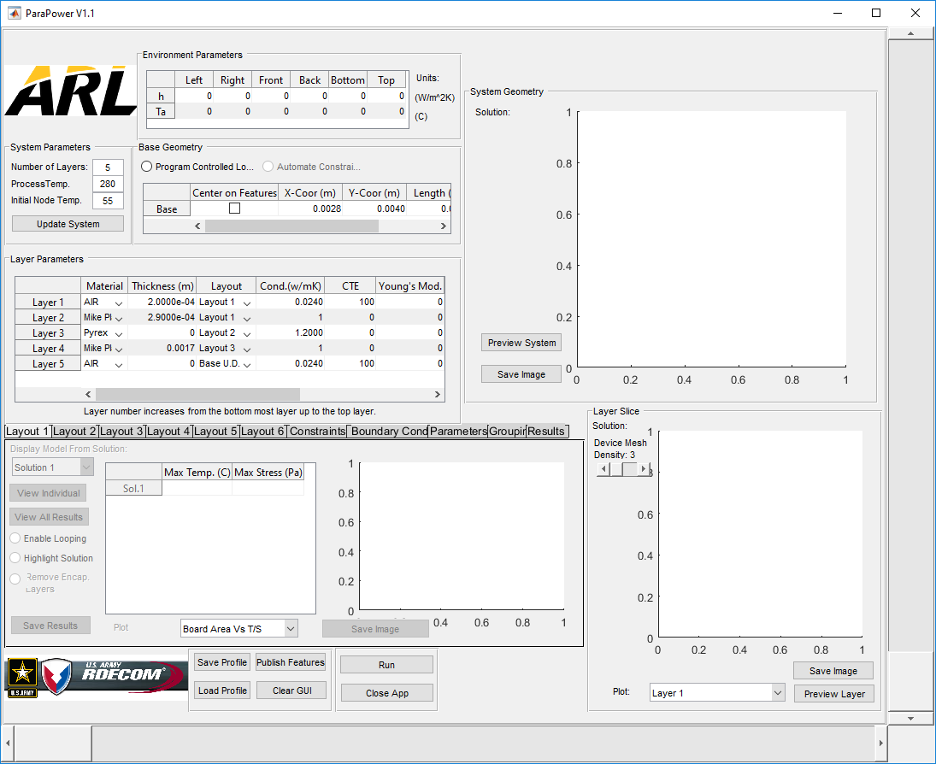

ParaPower is broken up into a number of different windows. These windows are Environmental Parameters, System Parameters, Base Geometry, Layer Slice, Layer Parameters, System Geometry, Executive Control, and the Tabular Windows. With the exception of the Tabular Windows, each of these windows will remain relatively constant throughout the setup process. The Tabular Windows will change based on the tab selected.

**Add numbered format, in addition to colored format, don’t be mean to colorblind**

When the In order to set up a simulation, the first step is to fill out the System Parameters window.

Windows in the GUI

All options for each window

Setting up a basic run

Parametric studies

PCM